Immigration

Twenty-three million people came to America from 1880 to 1920. These people were called Immigrants.

Who were they?
Immigrants came to the United States from Italy & Eastern Europe. These immigrants came to America because they were poor and wanted a better life.

Vocabulary

Immigrants – People who move into a new country.

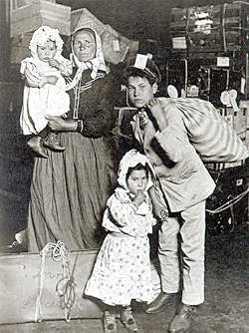
Immigrant family.

Sources:
Hopkinson, Deborah. Shutting out the Sky, 2003.

