Immigration in the Late 1800s & Early 1900s

Between 1880 and 1920, twenty-three million people came to America. These people were called Immigrants. They came looking for a better life.

Who were they?
In the Late 1800s & Early 1900s, immigrants came to the United States from all over the world. However, a large number of immigrants came from Italy & Eastern Europe.
Italian Immigrants were mainly farmers who didn’t own their own land, but were farm workers. They were often poor and many of them came to America to escape poverty.
Eastern European Immigrants were mainly Jews who came to America in the early 1900s. Before coming to America, many Eastern European Jews lived in small Jewish towns, called Shtetls. During the early 1900s, laws in Eastern Europe were passed making it illegal for Jews to own land or attend schools. Pogroms, or massacres of Jewish people, were also occurring at this time. Many Eastern European Jews came to America to find safety and escape discrimination.

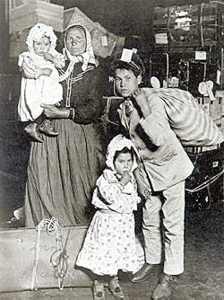
Immigrant family.
Immigration to the US by Decade
Decade | Immigration
1861-1870 | 2.3 Million
1871-1880 | 2.8 Million
1881-1890 | 5.2 Million
1891-1900 | 3.7 Million
1901-1910 | 8.8 Million
1911-1920 | 5.7 Million
1921-1930 | 4.1 Million

Ellis Island
Ellis Island is located in the Bay of New York City. In 1890, Congress designated Ellis Island as an immigration Station. By the end of 1910, six million immigrants had come through Ellis Island.
At Ellis Island, immigrants were tagged according to what language they spoke and they were marked with chalk according to their medical problems. They then were asked 32 background questions. Any immigrants containing contagious diseases were shipped back to their country of origin.

Vocabulary

Immigrants – People who move into a new country.

Poverty – The condition of being poor.

Shtetl – Jewish village found in Eastern Europe.

Pogroms – Organized Massacre of an ethnic group.

Tenement – A rundown, overcrowded apartment.

Life in America
The majority of immigrants settled in big cities where factory jobs were available. In these large cities, many immigrants settled within neighborhoods with people of similar ethnic backgrounds. Some of these neighborhoods included Little Italy, Chinatown, & Little Romania.
Many poor immigrants rented rooms in tenements. Tenements were rundown apartment buildings with poor lighting, poor ventilation, and few facilities. Ten to Twelve immigrants would often share a tenement room, splitting the rent between them.
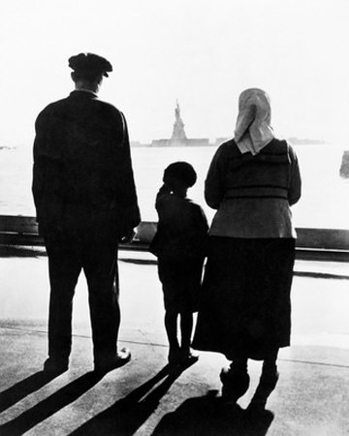
Immigrants arriving in America.
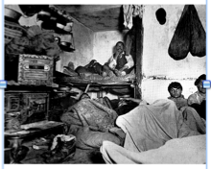
Immigrants living in a crowded tenement.

Changing America
The immigrants that came to America during the late 1800s & early 1900s, changed the face of America. Not only did they bring their language, customs, and culture, but they also brought their determination and strong work ethic. All of this helped shape America into the melting pot it is today.

European Emigration to the U.S. 1901-1910
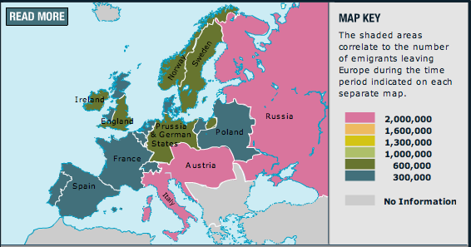

Sources:
Hopkinson, Deborah. Shutting out the Sky, 2003.
http://www.migrationinformation.org/datahub/charts/final.immig.shtml
http://www.pbs.org/destinationamerica/usim_wn_flash.html

